History of Science and Technology Technology for Green Energy

EPMAGAZINE

This handbook has been created in order to help EPM editorial board members during their whole editorial progression. From the beginning with nothing more than few people who want to work on the magazine to the end with their final product, the issue.
So, let’s start this journey step by step.
2012
From nothing to the issue

INDEX
European Editorial job
- Searching for articles | 3
- Issuing EPM – Collection of articles | 3
- Issuing EPM – First check (issuing check form) | 4
- Share the articles to the Local Editorial Boards (only suitable ones) | 4

Local Editorial job
- Receiving and checking the articles (article check form) | 5
- Article pagination process (only corrected and completed articles) | 5
- Checking paginated articles by the author and teacher | 6
- Completing the whole issue with index, covers and editorial pages | 6

Publication
- Print the issue | 7
- Send newsletters | 7
- Spread the news on internet | 7

Forms
- Submission Form | 8
- Issuing Check Form | 11
- Article Check Form | 12
- Form for Referee | 13

European Editorial Job

Searching for articles
The first step, in order to obtain an issue, is to have articles to work on.
There are two parallel ways to do so: the first one is to search for writers; the second one is to be the writer. So, the first way is to search among people we know who want to be writers. Otherwise we can send “Calls for submission of contributions (Articles, FunPages, News)”, aka newsletters by Mail Chimp, always keeping in mind that ours is a magazine from students to students about history of science and technology & TGE. This is a great opportunity to everybody to see his/her own name published in an international magazine like ours.
The second way is to write an article by ourselves. So, if we like to write and we have the possibility, why don’t we write contributions? Of course we can’t copy an article written by someone else and put our name on it, this is unfair for us, for the real author of the article and whoever will read the magazine. Every article must go through different controls in order to make sure it can be published.
In both ways the Submission Form (look page. 8) is needed. It is a form to be filled by the author of the article; in fact, it contains the needed author’s and article data.
Search for writers could be troublesome; anyway, it is our main target to involve schools and universities form all over Europe, at least. Who knows how many schools in the world want to join a magazine like EPM but they don’t know of its existence.

Issuing EPM – Collection of articles
After we have found writers, we have to collect articles and all the features related to it, like pictures, bibliography and iconography, and so on.
Then we have to send the whole material to issuingepm@epmagazine.org. “Issuing EPM” is an Editorial Board, chosen year by year, who has the duty to centralize the managing of the articles. In fact all the articles will be sent to it and from it the articles will be shared to the Editorial Boards. This centralization is necessary in order to have balanced issues. In other words, in a European magazine there cannot be articles only from a country or articles about one topic only. It needs to have a variety of article of different Nations and of different topics.

Issuing EPM – First check (issuing check form)
The second duty of Issuing EPM is to do a first check of the article. A first check means a check regarding the content, plagiarism and topic, the files, both languages and pictures, and the information, author and school. For this the Issuing Check Form is needed (look page 11).
If the article doesn’t have the minimum requirement, such as it is not about a topic of EPM or doesn’t have pictures, it must be sent back with a request to recheck it or ask for the missing file.

Share the articles to the Local Editorial Boards (only suitable ones)
Once everything should be fine, we can go on with the distribution of the articles to the Local Editorial Boards, of course only the suitable ones. The distribution must be done keeping in mind that the issue needs at least an article for each topic and the articles should be from different countries. If we can accomplish this task we will show the readers what our European magazine is made of!

Local Editorial Job

Receiving and checking the articles (article check form)
Now is where the Local Editorial Board starts to care for the issue. They begin their activities checking the articles sent by the Issuing EPM. This time the article will be checked completely with the Article Check Form (see page 12). The Issuing Check Form is necessary in order to have an idea of the article. Now we’ll check if the article has got all the suitable information, in fact the Article Check Form has more steps than the Issuing Check Form. At the same time we need the Form for the Referee (see page 13); it is a form used by the referees who check the article as regards English, Topic and History.

Article pagination process (only corrected and completed articles)
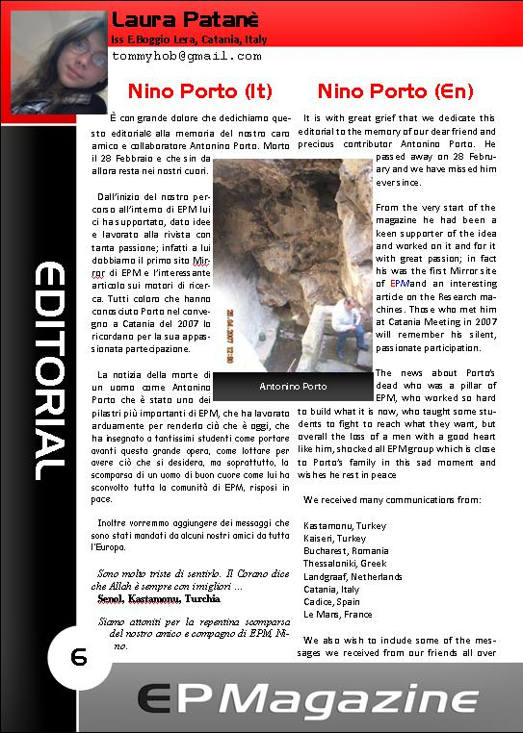
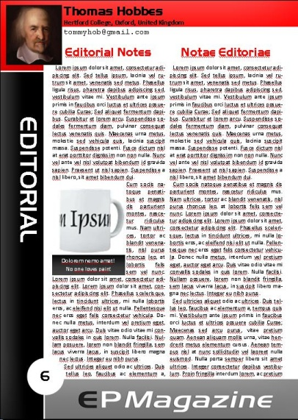
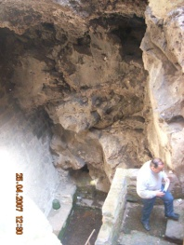
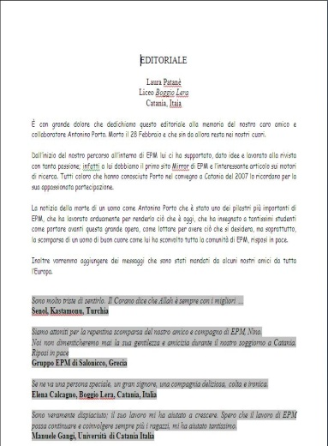
Pagination process time! This process takes place in order to join the text and the pictures of the article with the layout. At the end we’ll obtain a paginated article which can be approximately printed. Only articles which have passed the control of the Check Form can be paginated.

The process consists in copying the text of the article and the pictures into the layout and modifying them making them fit the layout. The main rule of the pagination process is that the layout mustn’t be modified. In any way, the text must be modified to fit the layout, not the contrary.
Once the text is copied and pasted onto the layout, its font must be changed into the layout fonts. It includes size, colour, type, and so on. Then the same must be done for the pictures and its captions. Finally we need to check if there are blank spaces and fill them, if the sentences are aligned and if it is eye catching.

Checking paginated articles by the author and teacher
Finally the pagination process is over! Now all that we need to do is to send them to their authors and teachers and see if they agree with our work. We must have the authors’ agreement of the article before we print it. If the author doesn’t like any arrangement of the pagination we have to modify them within the limits of the layout.
Once we have obtained the agreement of all authors, we can go on and complete the issue!

Completing the whole issue with index, covers and editorial pages
Now that all the articles are paginated we have to put them together into one file, add the covers and create the index. The articles will be arranged following this order:

- Front cover;
- Inside front cover;
- Index;
- Editorial;
- General;
- News;
- 14/16 Section;
- FunPages;
- 17/19 Section;
- Technology for Green Energy;
- University;
- Inside back cover;
- Back cover.

Publication

Print the issue
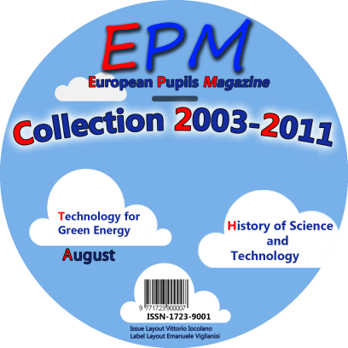
Finally we have got our issue! After a long journey we have finished it! However, have we really finished? Well, not exactly. Now it’s time to let everyone know this great news. First of all we have to print as many issues as we can for us, for our friends and for everyone who wants a copy. We’ll let them see the result of all the hard work that we have done, our pride, our issue.
Don’t forget about the CD! In fact we have also a CD that contains all the issues of EPM and need to be updated with the latest issue and burned!

Send newsletters
We have to inform also the people from all over the world sending them newsletters which contain all the news about the issue such as who has created it and where they can find it.

Spread the news on internet
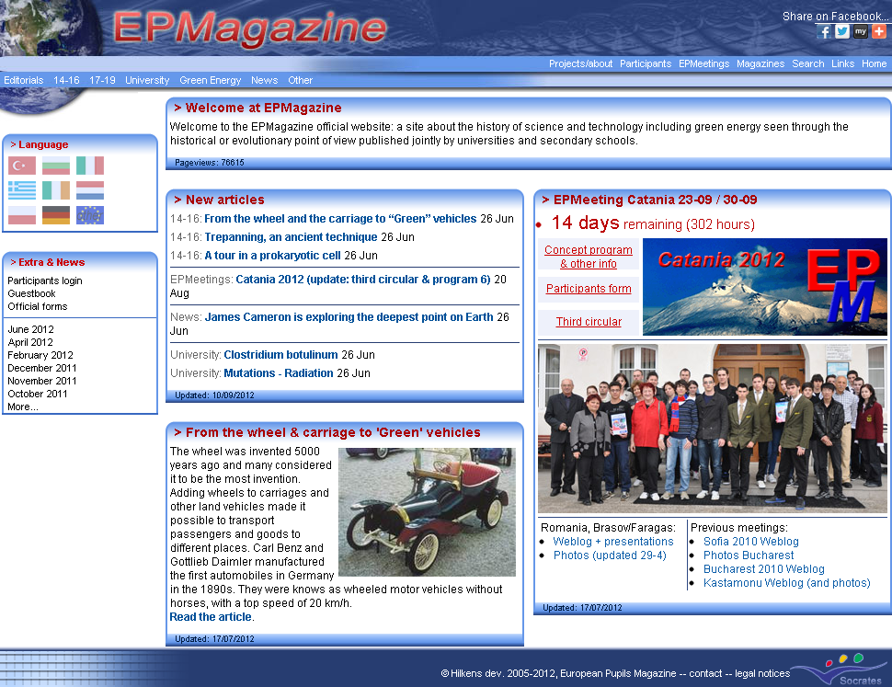
Furthermore we have to put online the entire file regarding the issue like in the official site (www.epmagazine.org) or Mediafire. In this way anybody can download and see them in their computer, and they can decide to print them for themselves or their friends.

History of Science and Technology
EUROPEAN PUPILS MAGAZINE

SUBMISSION FORM

Received by EPMagazine Editorial Board by fax/e-mail: ________________.2012
Forms to be filled in by MAIN AUTHOR and submitted both by
fax and e-mail to your National editorial Board or to fax ++39095327160 and ganges@alice.it

Title of paper: ___________________________________
Author(s): ___________________________________
Personal e-mail address: ________________@__________
Age(s): ___________
class(es): ___________
CORRESPONDING AUTHOR: ____________________________
Personal e-mail address: ________________@__________
school(s); include name of the School, its telephone & fax numbers, e-mail and full postal address:
_____________________________________________________________
_____________________________________________________________

CATEGORY OF YOUR PAPER - Please tick the category of your paper
◻ D General Section: unpublished work, up to 4 pages, including reference, tables and figures (3 pictures per page, at least).
◻ E News Section: unpublished report, up to 2 pages, including reference, tables and figures (3 pictures per page, at least).
◻ F 14 to 16 years old Section: unpublished work, up to 4 pages, including reference, tables and figures (4 pictures per page, at least).
◻ G Fun Section: unpublished stories, humours, and so on, up to 2 pages, including reference and images (4 pictures per page, at least).
◻ H 17 to 19 years old Section: unpublished work, up to 4 pages, including reference, tables and figures. (4 pictures per page, at least).
◻ I Technology for green energy Section: unpublished work, up to 2 pages, including reference, tables and figures (4 pictures per page, at least).
◻ L 19 to 24 years old University Section: unpublished work, up to 4 pages, including reference, tables and figures. (4 pictures per page, at least).

There is no competition opened for the 2011 and 2012 issues.

The Author(s) and the referred teacher confirm that the submitted paper is original, and no part is plagiarized by works written by other people.

Student(S)’ Signature ______________________________

Teacher’s Signature ______________________________

Teacher’s e-mail address ______________________________
History of Science and Technology
EUROPEAN PUPILS MAGAZINE

TEACHER’S NAME: ________________________________________
E-MAIL: ______________________@___________________
SPECIALiTY: ___________________________________________
SCHOOL: ___________________________________________________

TITLE OF THE ARTICLE ____________________________________

STUDENT’S NAME(s): ______________________________________

I confirm that:

- the article belongS to ______________________________
- the article is original: no part is neither totally nor partially plagiarized by other people.
- the article has NEVER been published elsewhere neither FULLY nOR PARTIALLY in WEB SITES, other magazines, BOOKS, AND SO ON.
- all reference (bibliography – iconography) have been checked.
- the article expresses the AUTHOR’s view
Signature

________________________________________

List of 10 keywords at least
English | Mother Language

Title IssuingEPM-CheckForm
CODE

Author(s’ Name Surname, mail@host.domain
Who is working: Name Surname, mail@host.domain

Submission form Signed and completed with keywords;
Conformity to the targets of the Magazine (history references, past, present and a possible future of the subject of the topic);
Correctness of Bibliography and Iconography information (see attached form);
4 images at least per page in graphic format, not less than 300 DPI of resolution;
Image captions both in English and in mother tongue;
Sent request of revision (__/__/12; __/__/12; __/__/12; __/__/12; __/__/12);
Refused for publication. Date: __/__/12 Reasons:
Sent to _________________________ (__/__/12)

Date Today / /12
Use: (blue font) if the requested information is ok
to be checked
missed data

Title Check-Form
Code

Author(s’ NAME(s), mailaddress@provider.xx

Who is working: NAME, mailaddress@provider.xx

Submission form Signed and completed with keywords;
Conformity to the targets of the Magazine (history references, past, present and a possible future of the subject of the topic);
Clarity of the presentation;
Didactic usefulness;
Originality; (Search for plagiarism both in English and in mother tongue);
Correctness of Web addresses (working links);
Correctness of Bibliography and Iconography information (see attached form);
English (tick only if it has been corrected);
Mother language (tick only if it has been corrected);
4 images at least per page in graphic format, not less than 300 DPI of resolution;
1 photo of the Author(s) in graphic format, not less than 300 DPI of resolution;
Image captions both in English and in mother tongue;
Sent request of revision (__/__/12; __/__/12; __/__/12; __/__/12; __/__/12);
Referees (sent material at __/__/12):
English ______________________@____________________ Tick as acceptance
Topic ______________________@____________________ Tick as acceptance
History ______________________@____________________ Tick as acceptance
Refused for publication. Date: __/__/12 Reasons:
Postponed to next issue

FILE PUBLISHER
The article is totally paginated with the graphical shape according to the layout rules;
The article keywords are highlighted according to the layout rules;
Sent Pub to Author for corrections & agreement;
Date Today / /12
Use: “” (blue font) if the requested information is ok
“✗” (red font) when some information is not ok yet (the colour will help you to single out them)

Form for the referees

Name: __________________________________________
Specialty: __________________________________________
E-mail: _____________________@___________________
Country: _____________________
Date to receive: / /2012
Date to referee: / /2012

TITLE OF THE REFERRED ARTICLE: ___________________________________________

AUTHOR(S): __________________________________________________________
SCHOOL: __________________________________________________________

CATEGORY OF THE PAPER: 14-16; 17-19; 19-24; Technol. For Green Energy

Results
- Accordance to the EPM content: Yes No
- Scientific content: Yes No
- English language: Clear Unclear

- Structure: _____________________________________________________
________________________________________________________________
________________________________________________________________

- Pictures: ______________________________________________________
________________________________________________________________
________________________________________________________________

- Interest: _______________________________________________________
________________________________________________________________
________________________________________________________________

- Originality: ____________________________________________________
________________________________________________________________
________________________________________________________________

- Other remarks: _________________________________________________
________________________________________________________________
________________________________________________________________

- THE ARTICLE IS TO BE PUBLISHED:
Yes No Yes after corrections

- Specific corrections (you can use other pages or sign them in the article with different fonts and color):
___________________________________________________________________________
___________________________________________________________________________
___________________________________________________________________________
___________________________________________________________________________
___________________________________________________________________________
___________________________________________________________________________

